- Download a sample CSV file of IPL player stats (include columns like player name, runs, matches, and some missing values). Load it into a pandas DataFrame and use isnull() and notnull() to print how many missing values are present in each column.

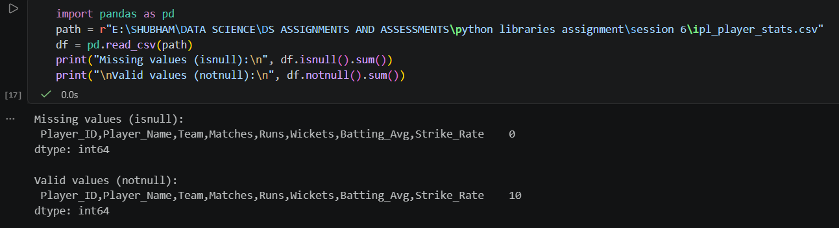

- Using the loaded IPL player stats DataFrame, apply dropna(axis=0, how='any') to remove all rows with any missing data and display the shape of the DataFrame before and after dropping.

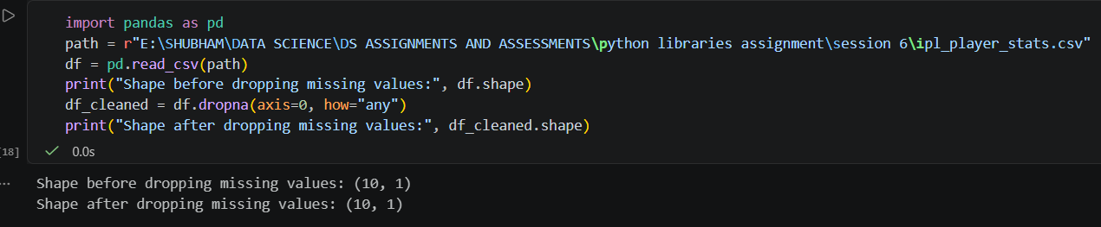

- For the 'runs' column in your IPL player stats DataFrame, use fillna() to replace missing values with the mean of the column. Print the updated column to verify the changes.

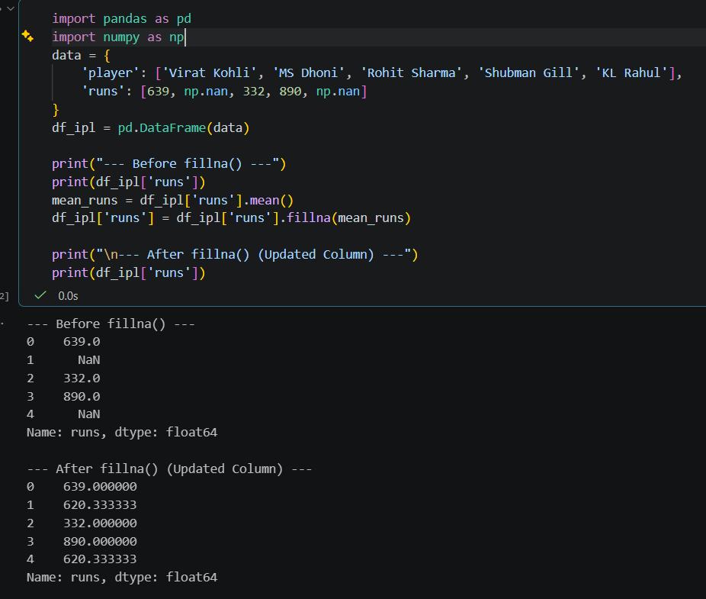

- Simulate a Zomato-style restaurant ratings dataset with some missing ratings. Use forward fill (method='ffill') to fill missing values in the ratings column, then use backward fill (method='bfill') for any remaining missing values. Show the before and after results.

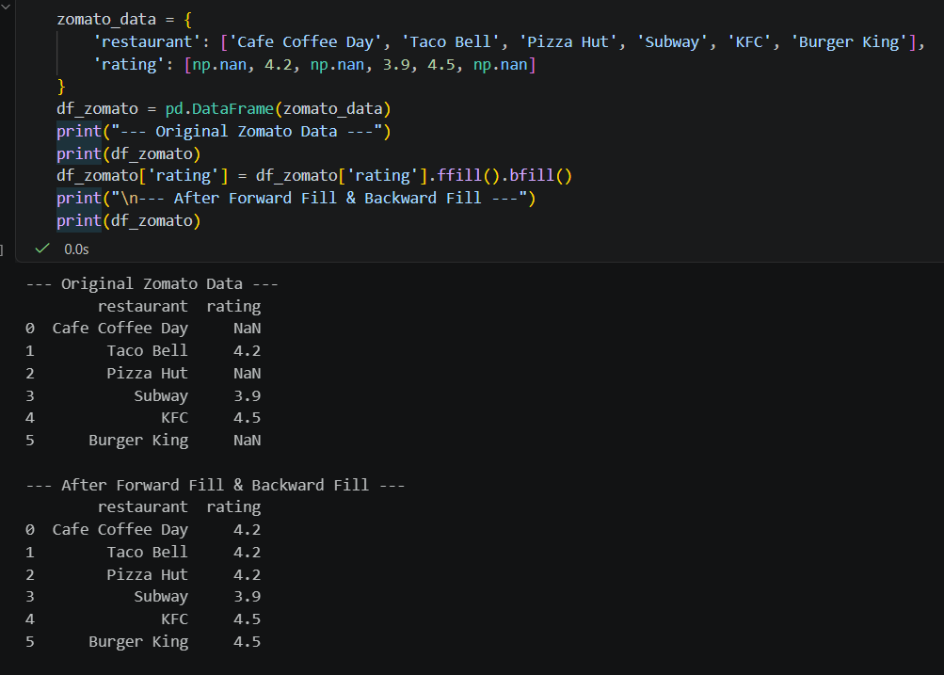

- Pick any one column with missing values from your dataset and explain which missingness mechanism (MCAR, MAR, or MNAR) is most likely and why, using 2-3 sentences. Think about whether the missing data is random or related to other factors in the dataset.

Missingness Mechanism Explanation
Column Selected: rating (from the Zomato dataset)
Likely Mechanism: MNAR (Missing Not at Random)
Why: Missingness in restaurant ratings is often directly related to the unobserved value itself; customers are far less likely to leave a review if they had a completely mediocre, unmemorable experience, or if the restaurant is brand new and hasn't established a reputation. Because the probability of the data missing depends on the missing value itself (the average/unexpressed sentiment), it falls under MNAR.

